**Project Design Phase-I**

**Solution Architecture**

|  |  |
| --- | --- |
| Date | 19 September 2022 |
| Team ID | PNT2022TMID48513 |
| Project Name | Project - IOT based smart crop protection system for agriculture |
| Maximum Marks | 4 Marks |

**Software Architecture**

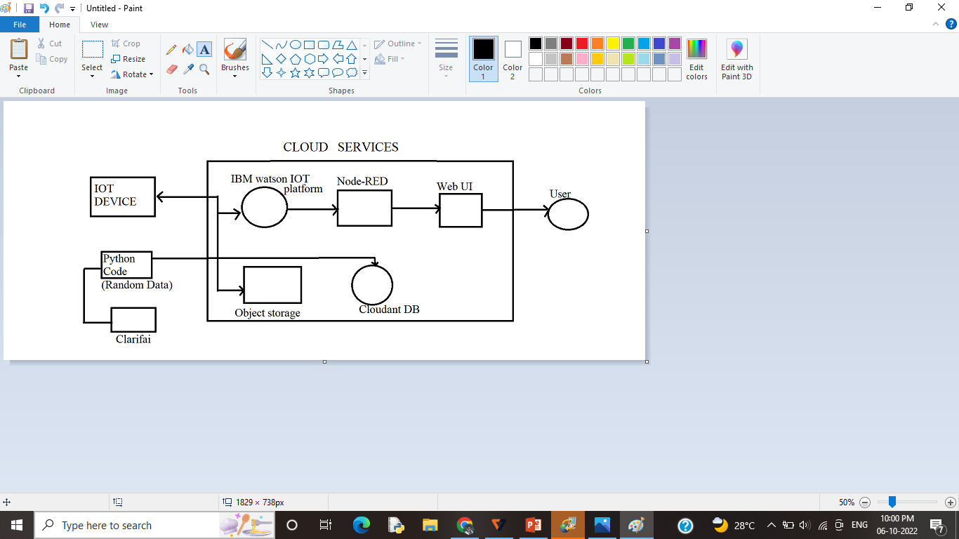

**Hardware Architecture**

